CN Lab 03 Home Task:

Name: Owais Ali Khan

Section: 6-F

Roll no: 21K-3298

Task 01:
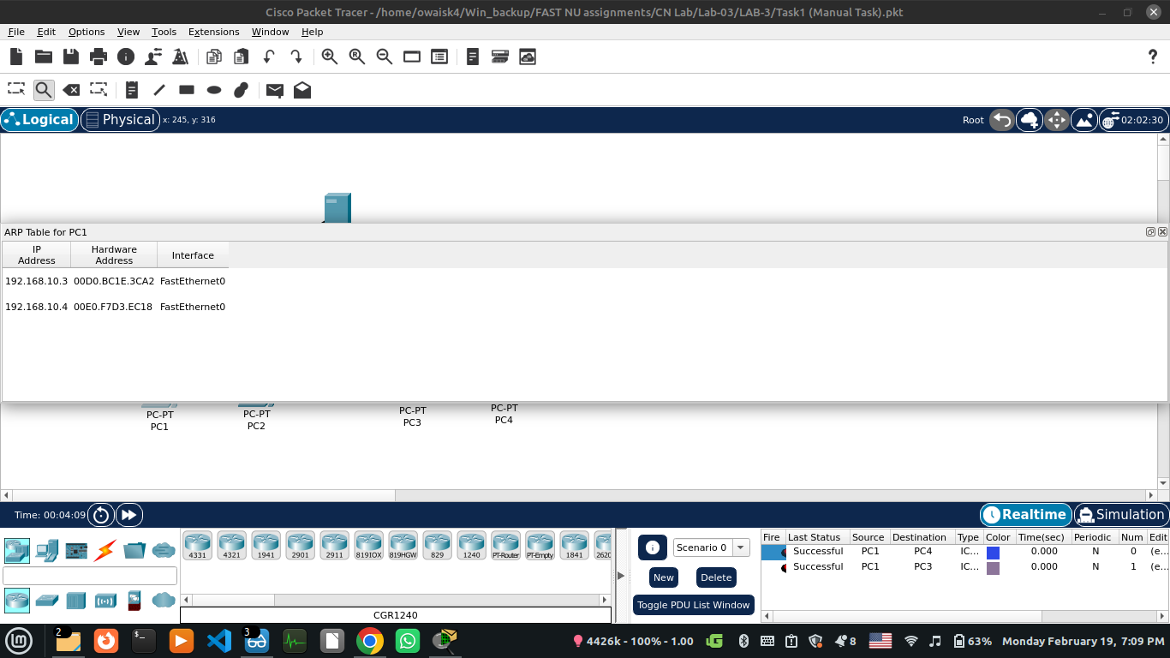
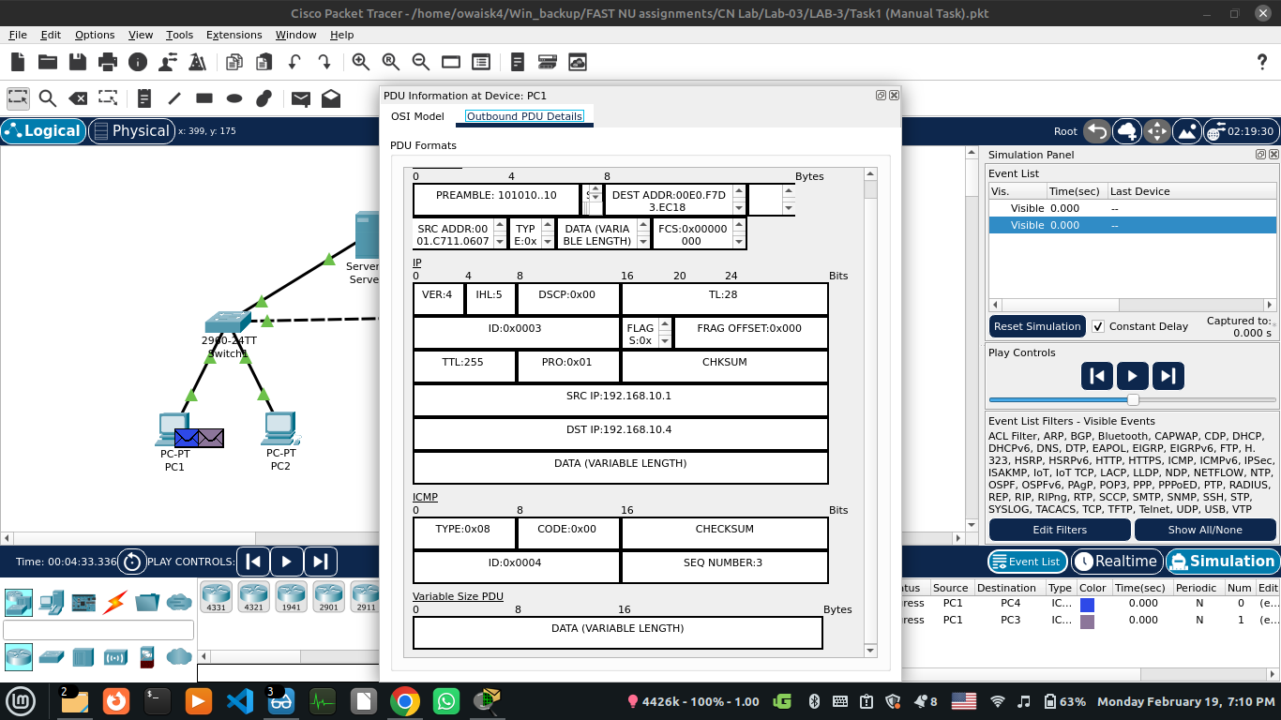

Task 04:
The packet tracer shows the working of hubs and switches as follows:
HUB broadcast the data to all connected devices. Whereas, the SWITCH channels
that data to specific connected devices using some logic in the form of tables.

Task 05:
The default view for Packet Tracer is Logical, which is equivalent to creating a logical diagram for the network.
The physical mode shows the relationships of the network devices and also factors like building and distance factors in making the design.

